certificate of completion
this certificate is presented to

NAME
FOR SUCCESSFUL COMPLETION OF
Module 1: Family Dynamics with Dr. Joseph Crumbley
(1) hours
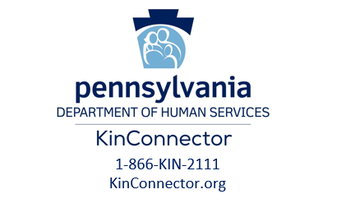
Tia-Maria Smith, PA KinConnector

DATE

